Valencia Johnrel Dave BSIT III – A

TOPOLOGY
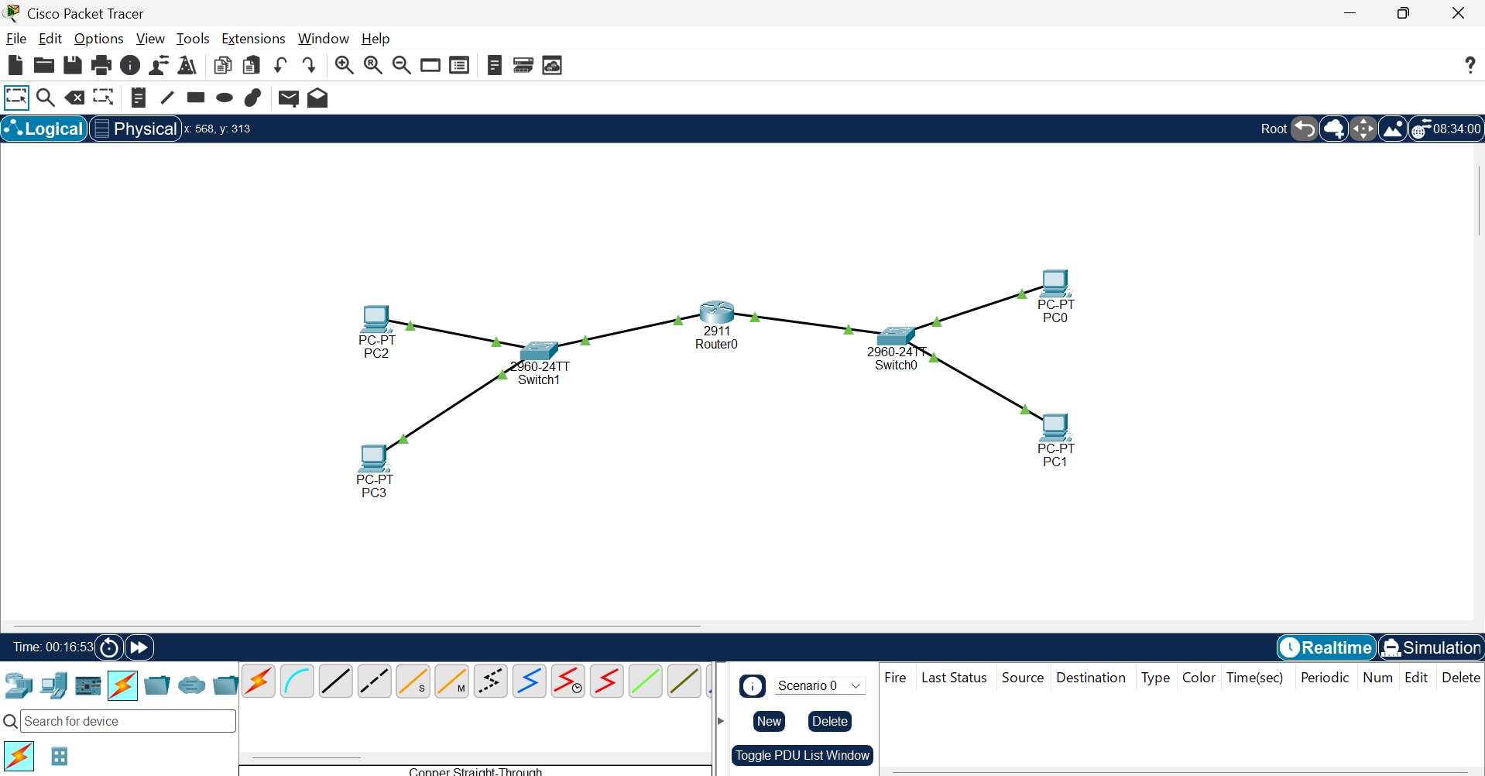
PINGS
Pc1-pc3
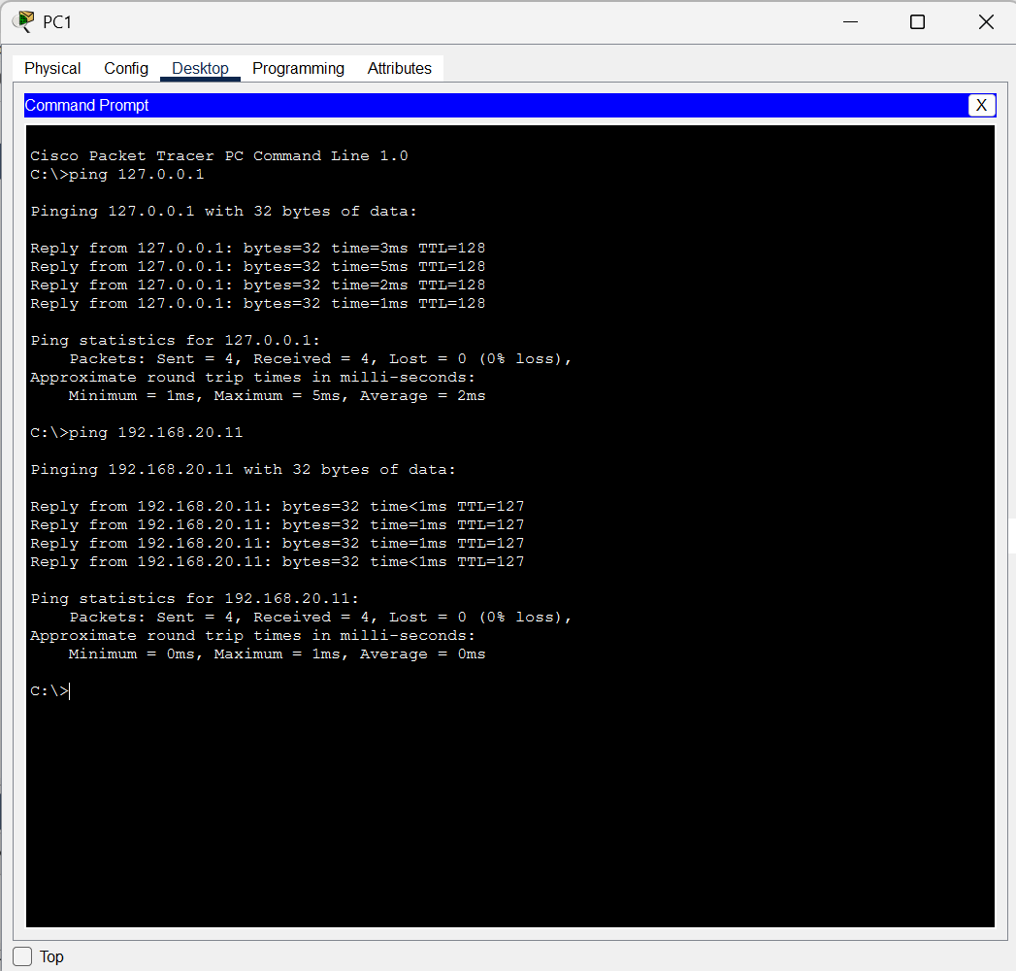
Pc3-pc1
